

To: City Executive Board
Council

Dates: 4 April 2012
23rd April 2012

Report of: Head of Corporate Assets

Title of Report: LETTING OF RAMSAY HOUSE, ST EBBE’S STREET, OXFORD

Summary and Recommendations

Purpose of report: To seek approval to the letting of 2nd Floor Ramsay House, St Ebbe’s Street including the necessary capital expenditure works to facilitate the letting. This replaces the previously approved letting.

Key decision? No

Executive lead member: Councillor Ed Turner

Report approved by: David Edwards, Executive Director

Finance: Jacqueline Yates

Legal: Steve Smith

Recommendation(s):
The City Executive Board is recommended to:

1. Approve the proposed letting of Ramsay House, 10 St Ebbe’s Street Oxford on the terms as detailed in the Not for Publication Appendix 4 of this Report and otherwise on terms and conditions to be approved by the Head of Corporate Assets.

2. Give authority to the Head of Corporate Assets to vary the proposed tenant terms as detailed herein provided the transaction continues to represent bet consideration.

3. Make recommendation to Council to include a capital budget of £300,000 in the Capital Programme for 2012/13 for refurbishment of the comfort cooling system at Ramsay House

Council is recommended to:

1. Agree a variation to the 2012/3 budget to allow a capital expenditure of £300,000 for works to Ramsay House

Appendices

Appendix 1 - Plan of Site
Appendix 2 - Risk Register
Appendix 3 - Not for publication confidential appendix
Appendix 4 – Not for publication confidential appendix

Background

- Approval to a letting to The Gym Ltd was given in a Single Member Decision on 2 December 2011. The company subsequently chose to reduce their rental offer and improved terms were subsequently agreed with an alternative party. The reduced offer from The Gym Ltd remains on the table.

- This report seeks approval to grant a new lease of Ramsay House to Natural Motion Ltd. The site is shown hatched on the plan attached at Appendix 1.

- The property has been occupied by Oxford City Council as an administrative office building and has been vacated as a consequence of the Offices for the Future Project.

- The building has been marketed since March 2011 by the appointed agents, VSL and Partners, on a both a long leasehold sale and ‘to let’ basis. The following initiatives have been undertaken:

    - Marketing Board on site
    - A4 printed glossy brochure with electronic pdf version
    - Advertisement in the Oxford Times In Business Magazine
    - Online advertisement on EG property link
    - Online advertisement on VSL’s web site
    - Online City Council Web site

- There has been little interest in a long leasehold sale and our agents have recommended that the Council move forward on the basis of the proposed letting.

- A cash flow analysis of the letting to Natural Motion against that of The Gym Ltd is attached as not for publication confidential Appendix 3.

- The letting to Natural Motion is dependant upon capital budget programme changes to allow the replacement of the building’s comfort cooling system.

Existing Comfort Cooling System
- The system was installed in 1998 at building construction, and has been maintained on a contract basis by Oxford Refrigeration and Air Conditioning Limited (ORAC). Even with regular maintenance the system is outdated and requires increasingly frequent maintenance works.

- The system contains a refrigerant gas which was banned for new installations from 2010 and will become illegal to use in any system after 2015. Between 2010 and 2015 it is permitted to use re-cycled refrigerant for repairs, but stocks of this are becoming limited. The system in Ramsay House does not enable the use of alternative refrigerant gas in the existing equipment.

- Replacement of the constituent parts of the system is uneconomic and would not offer best value and longest life for the system as a whole.

Proposed Comfort Cooling System

- The proposed system would provide an installation which would comply with current regulations, have a life of approximately 15 years and be a more energy efficient installation than the current system

- The works which are to be carried out will benefit the building for any future lettings or sales and therefore increase the value of the building.

- In summary, the proposed letting includes:

    - Granting, on commercial terms, a new lease broadly on the terms as set out in the confidential not for publication Appendix 4.
    - Capital expenditure of £300,000 to upgrade the comfort cooling system, works which will enhance the building for this letting and for future value

Planning Implications

- No additional planning consents are required

Risk Implications

- A risk assessment has been undertaken and the risk register is attached as Appendix 2.

Sustainability and Climate Change Implications

- The vacation of the property by the Council will save 150 tonnes of CO2 per year which will contribute to the Council’s 2012/13 anticipated annual target of saving 500 tonnes of CO2.

Equalities Implications

- No implications.

Financial Implications

18. The capital spend of £300,000 for the refurbishment of the building may be financed from the first 12 months rental received, although there is currently no provision in the Council’s capital programme.

- The terms allow for the building to be refurbished (aside from the air conditioning) without any capital outlay by the Council.

- The proposal, as outlined in the confidential not for publication Appendix 4, will provide substantial income after the rent free period has expired. It will also ensure that the costs of holding the building vacant will be minimised.

- The tenant will pay the Council’s reasonable legal and surveyor’s fees incurred.

- Appropriate due diligence on the prospective tenant’s accounts have been undertaken and have confirmed that the covenant is acceptable.

Legal Implications

- The order for the replacement of the comfort cooling system will only be placed after the prospective tenant has entered into an agreement for lease committing the tenant to entering into the lease upon practical completion of the works.

- Under the terms of section 123 of the Local Government Act 1972, the Council is required to obtain the best consideration reasonably obtainable. The property has been extensively marketed with appropriate certification from the Council's VSL and Partners being provided.

Issues

- The letting would allow for the property to be marketed as an investment sale to create a capital receipt if required by the Council at a point in the future.

Name and contact details of author: Julia Castle
Corporate Assets
jcastle@oxford.gov.uk
Extension: 2223

Version number: 3

Appendix 1 – Plan of Premises

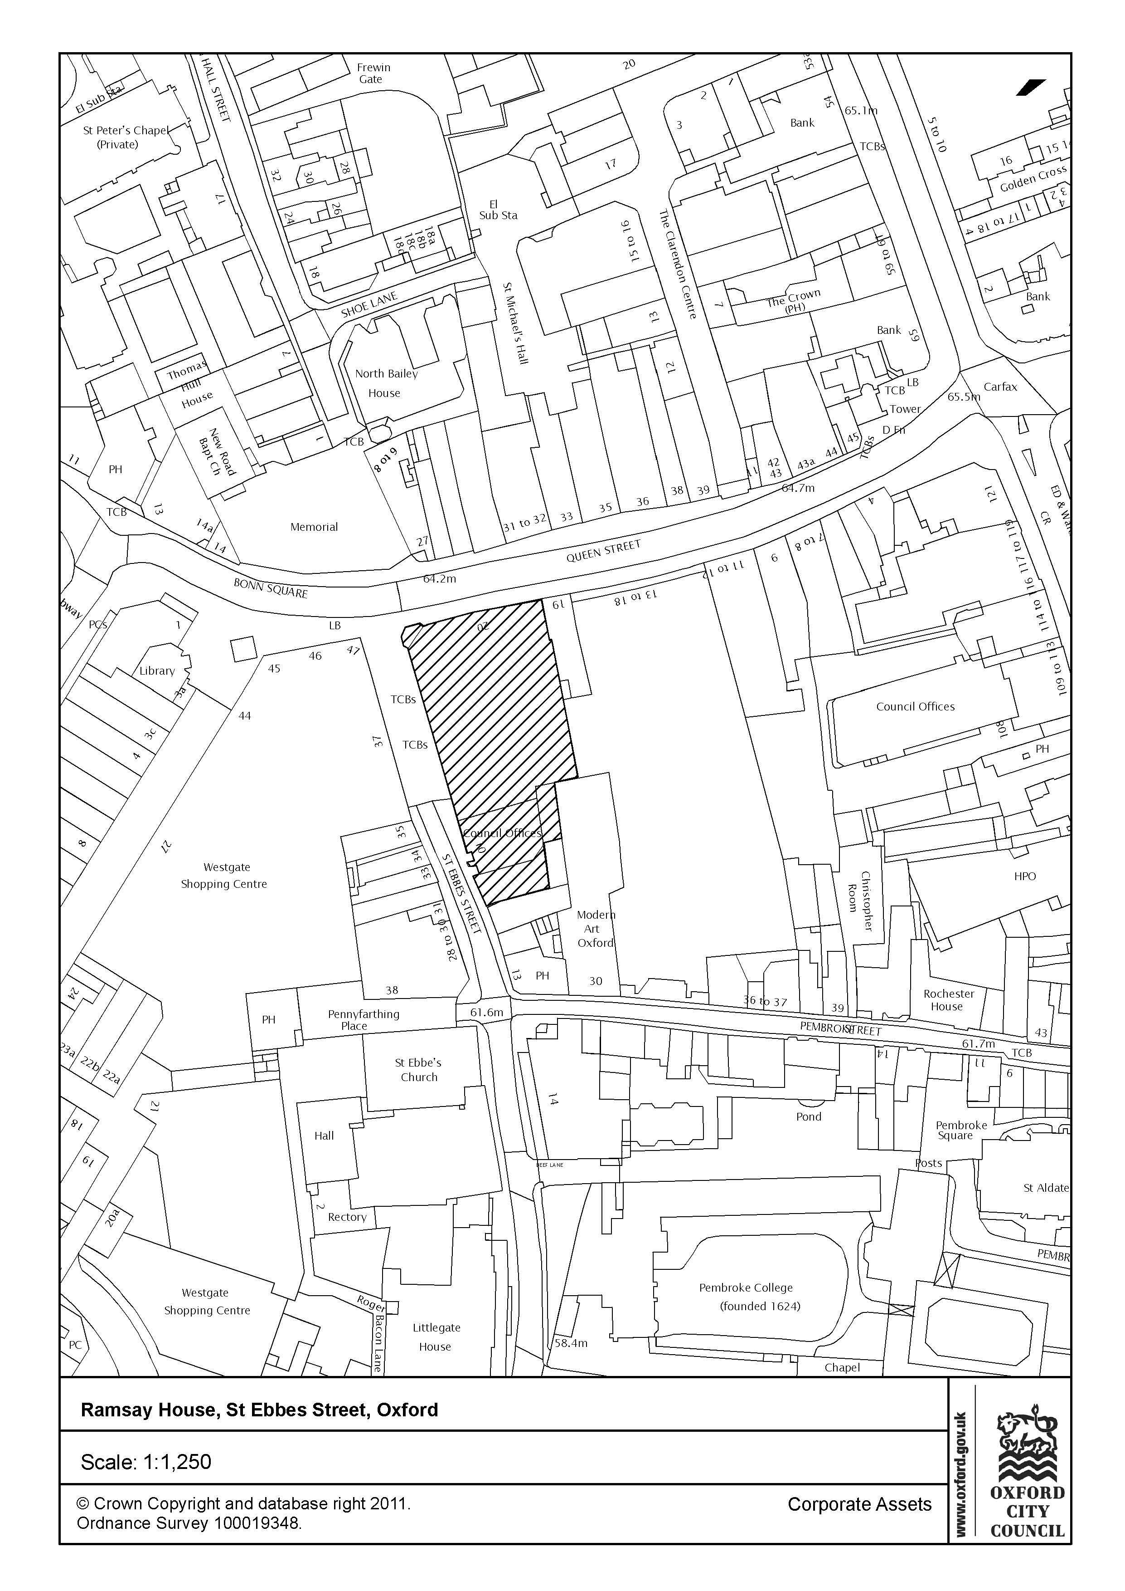
Appendix 2 CEB Report Risk Register – Approval to grant a lease on Ramasy House, St Ebbes Street, Oxford
Risk Score Impact Score: 1 = Insignificant; 2 = Minor; 3 = Moderate; 4 = Major; 5 = Catastrophic
Probability Score: 1 = Rare; 2 = Unlikely; 3 = Possible; 4 = Likely; 5 = Almost Certain

No. | Risk Description  Link to Corporate Objectives | Gross Risk |  | Cause of Risk | Mitigation | Net Risk |  | Further Management of Risk:  Transfer/Accept/Reduce/Avoid |  | Monitoring Effectiveness |  |  |  | Current Risk
1. | Negotiations fail with proposed Tenant | I  4 | P  3 | Tenant/OCC fails to agree legal terms. | Mitigating Control:  Close contact during legal process.  Level of Effectiveness:  (HML) M | I  3 | P  2 | Action:  Ongoing contact throughout process to ensure parties still interested.  Action Owner:  Julia Castle | Outcome Required:  Successful negotiation.  Milestone Date:  March 2012 | Q  1 | Q  2 | Q  3 | Q4 | I | P
2 | Negotiations fail with proposed Tenant | I  4 | P  4 | The tenants structural survey highlights unforeseen issues | Mitigating Control:  Close contact during process.  Level of Effectiveness:  (HML) L | I  3 | P  3 | Action:  Liaise with tenant to overcome any issues which may arise  Action Owner  Julia Castle | Outcome Required:  No issues arise.  Milestone Date March 2012 | Q  1 | Q  2 | Q  3 | Q4 | I | P
3. | Negotiations fail with proposed Tenant | I  5 | P  3 | Landlord’s Works to replace air conditioning over runs or is more costly than originally estimated | Mitigating Control:  Close contact between tenant, Corporate Assets, contractors and advisors  Level of Effectiveness:  (HML) M | I  3 | P  3 | Action:  Ongoing contact throughout process to ensure consent is granted  Action Owner:  Julia Castle | Outcome Required:  Successful negotiation.  Milestone Date:April 2012 | Q  1 | Q  2 | Q  3 | Q4 | I | P
4 | Works are not completed on time | I  4 | P  3 | The contract overruns | Mitigating Control:  Close contact during process, effective procurement process  Level of Effectiveness:  (HML) M | I  3 | P  3 | Action:  Liaison with procurement and appointed consultant  Action Owner  John Bellenger | Outcome Required:  No issues arise.  Milestone Date July 2012 | Q  1 | Q  2 | Q  3 | Q4 | I | P
5 | Works are more costly than estimated | I  4 | P  3 | Landlord’s Works to replace air conditioning over runs | Mitigating Control:  Close contact between contractor, Corporate Assets, contractors and advisors. Effective procurement process.  Level of Effectiveness:  (HML) M | I  3 | P  3 | Action:  Liaison with procurement team and appointed consultant  Action Owner:  John Bellenger | Outcome Required:  Successful negotiation.  Milestone Date:July 2012 | Q  1 | Q  2 | Q  3 | Q4 | I | P
6 | Works not carried out correctly | 4 | 2 | Lack of correct brief and contract | Liaison between contract, consultant and procurement teams.  Level of effectiveness M | 2 | 2 | Action:  Liaison with procurement team and appointed consultant  Action Owner:  John Bellenger | Outcome Required:  Successful negotiation.  Milestone Date:July 2012

